# Calibrating a Potentiometer

To begin this lab, type a 0 (zero) and press Enter in the Serial Monitor’s input area. Make sure the Newline option is selected at the bottom of the monitor window.

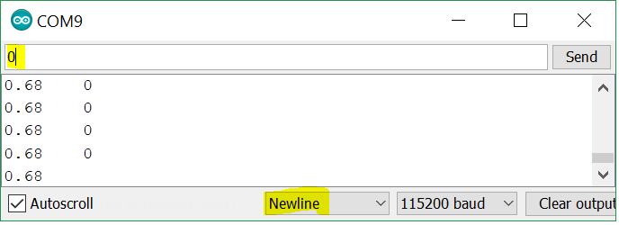

The monitor should is showing two columns of numbers; Volts and Degrees. Degrees are not yet calibrated, so the value is showing as 0. You need to perform a calibration to accurately display Degrees.

# Gather Data Points

To perform the calibration you’ll need to have some voltage measurements that correspond to known angles. When calibrating a sensor, it is always best to get multiple readings, being sure to include the extreme ranges of the device or mechanism. In this case we’ll get readings from 0 degrees up to 180 degrees, the full range of the gauge.

Write down the voltages for each of the following potentiometer positions.

|  |  |
| --- | --- |
| Degrees | Volts |
| 0 |  |
| 90 |  |
| 180 |  |

This is a linear potentiometer, so the relationship between voltage and angle is reasonably consistent throughout the potentiometer’s full range.

Look at the voltage for 180 degrees. Is it double that of 90 degrees? If not, why isn’t it?

Try subtracting the voltage at 0 degrees from the 90 and 180 degree voltage readings. Now the adjusted voltage for 180 degrees should be very nearly twice the adjusted voltage at 90. Now you can see the linear relationship.

# Determining the Calibration Factors

First, make note of the voltage reading at 0 degrees. This offset voltage needs to be accounted for in our calibration.

Offset = voltage at 0 degrees

By subtracting the offset from our voltage readings, we can use a simple scaling factor to calculate the angle for any voltage. This scaling factor is the ratio between degrees and volts, or degrees/volt.

Apply the voltage reading you had at 180 degrees to the following formula to derive the scaling factor.

|  |  |
| --- | --- |
| Scale = | 180 |
| ( volts180 – offset ) |

# Apply the Calibration

Now apply your Offset and Scale factors. Type your offset value into the Serial Monitor and press Enter. You’ll then be prompted for the Scaling factor. Enter that as well.

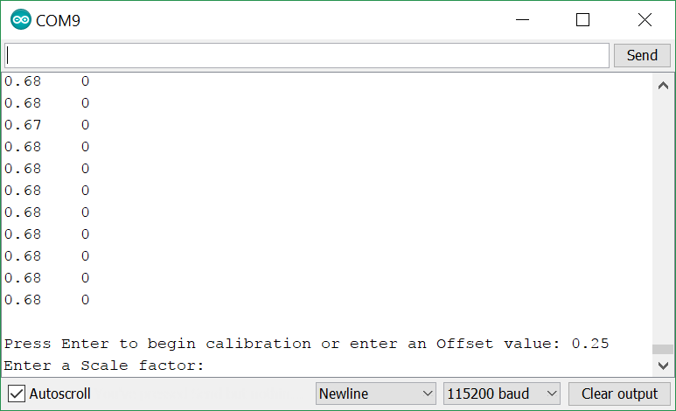

Observe the calibrated output for several readings across the full range of the gauge. How much error are you seeing (+/- degrees)?